**Accessibility Testing Screenshots - CivicTech**

**Automation Tools:**

**Wave (Dark Mode):**

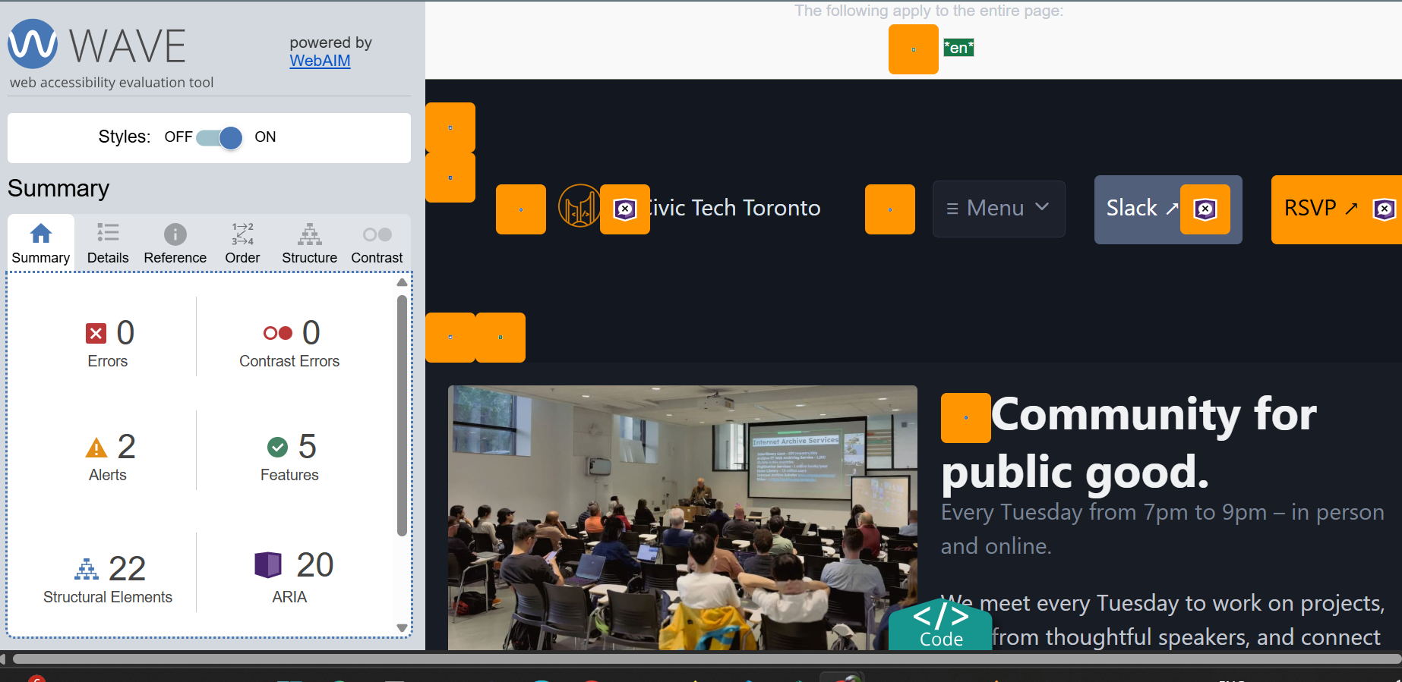

**Axe (Light Mode):**

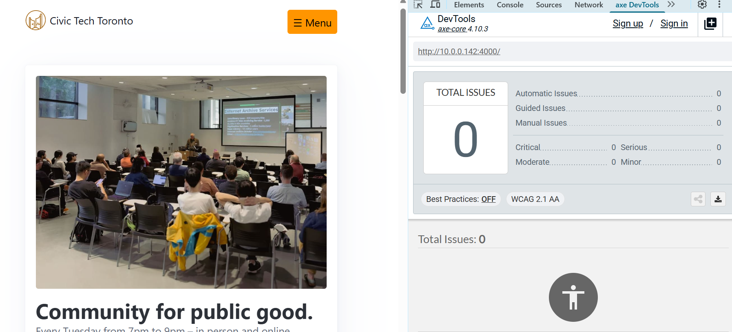

**Tabbing – Homepage:**

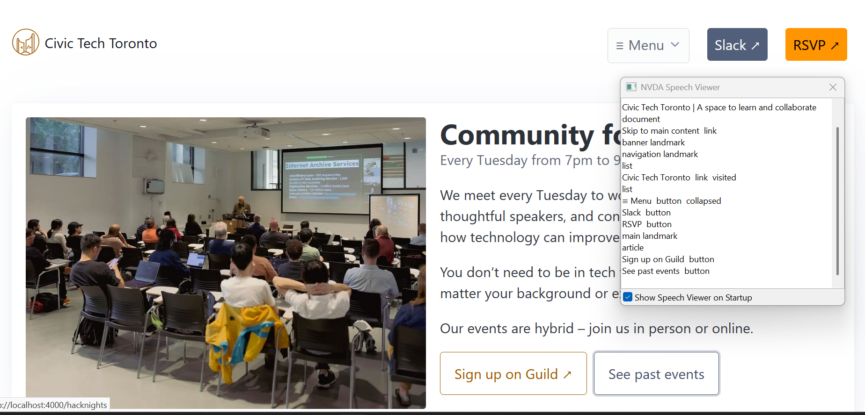

**Image: Alt Text:**

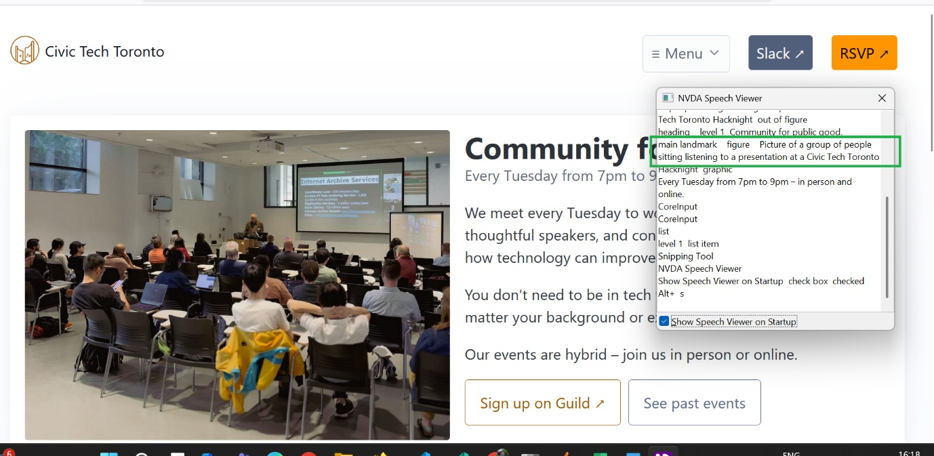

**Headers**

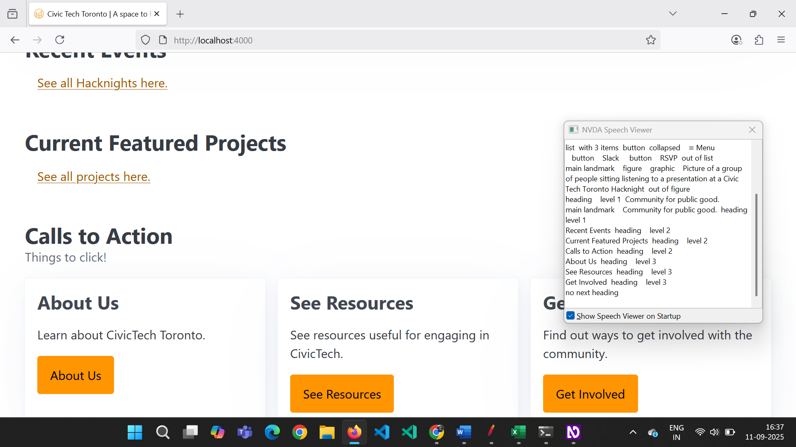

**Down Arrow Key**

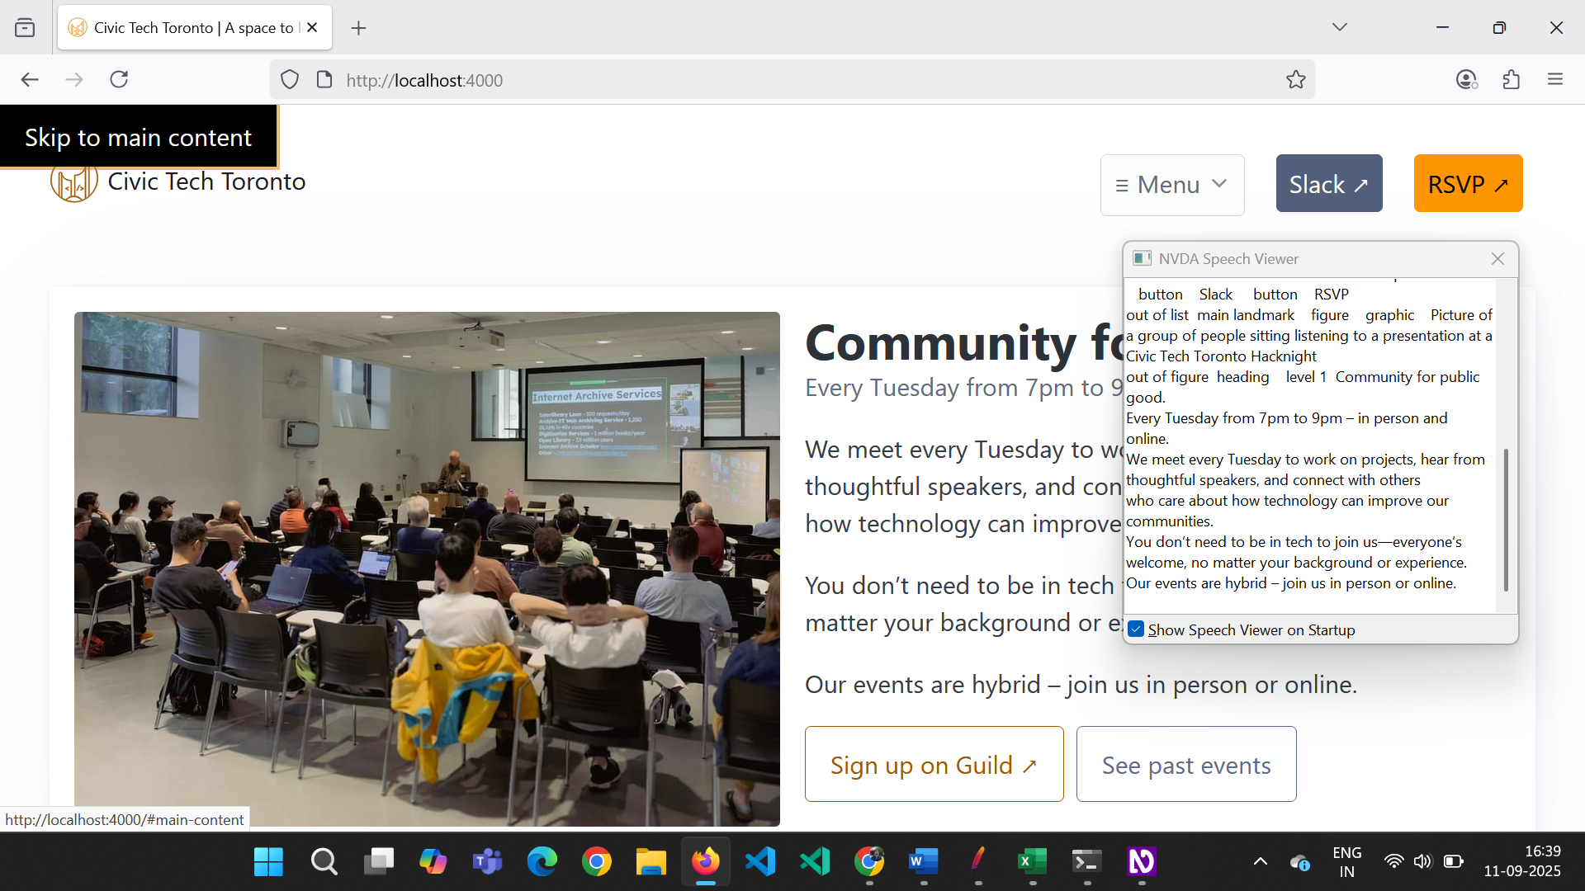

**Read Whole Page (About Us)**

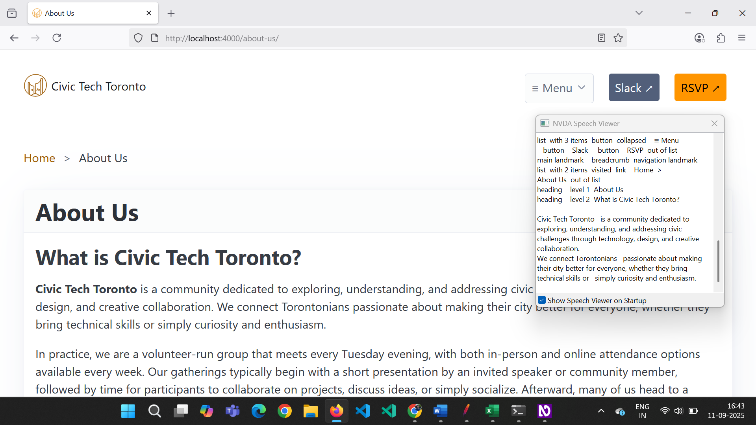

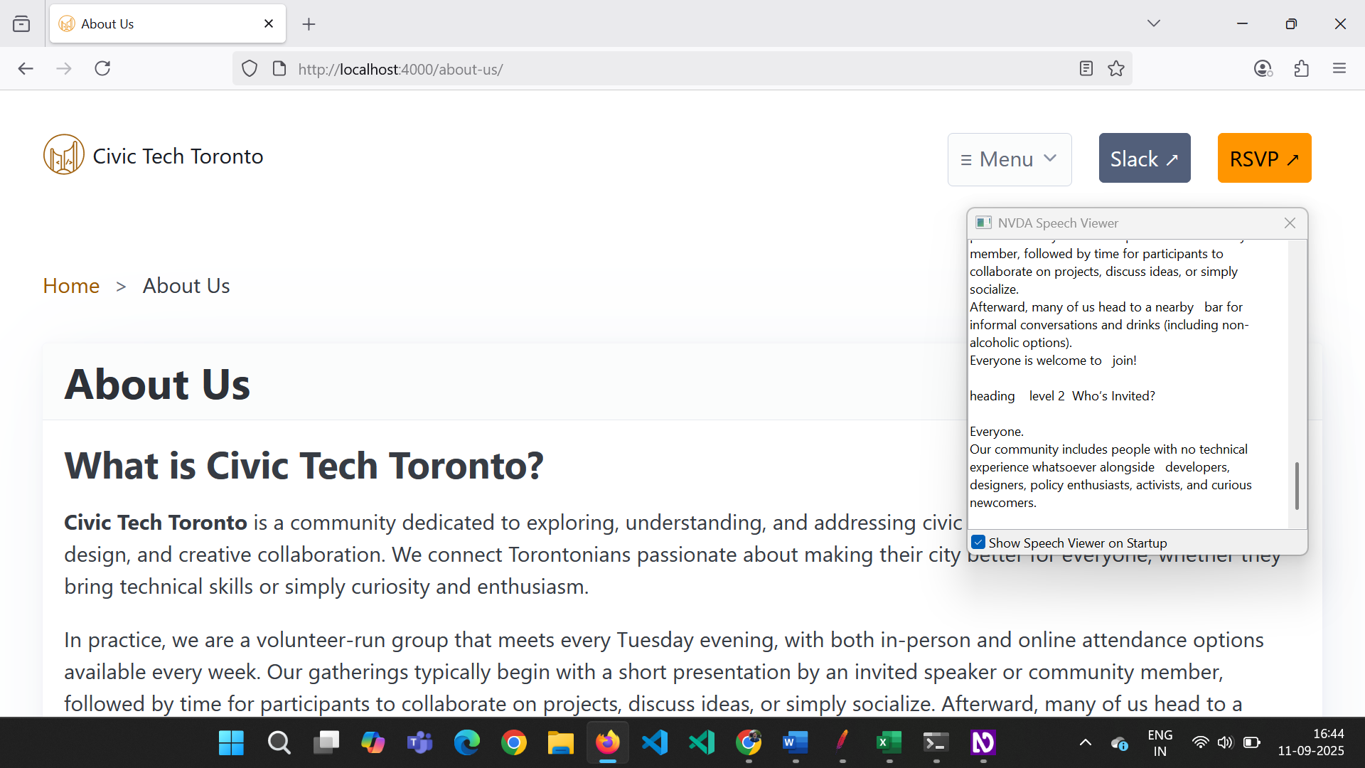

**Colour Contrast:**

**Menu (Dark Mode)**

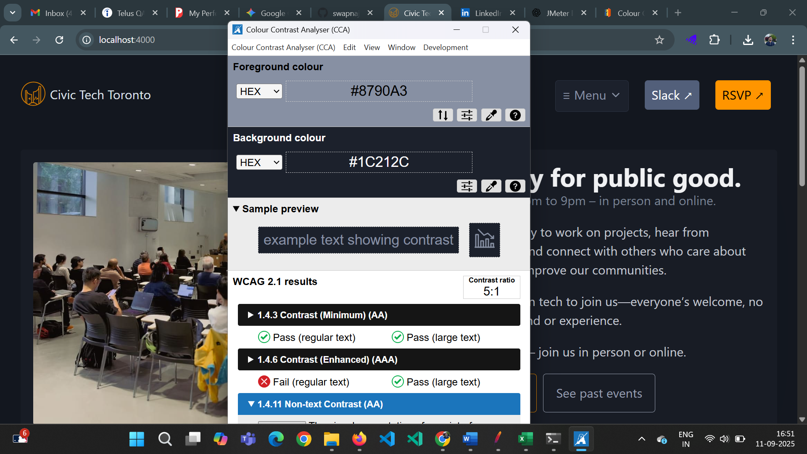

**Issue - Text - Every Tuesday from 7pm to 9pm – in person and online.**

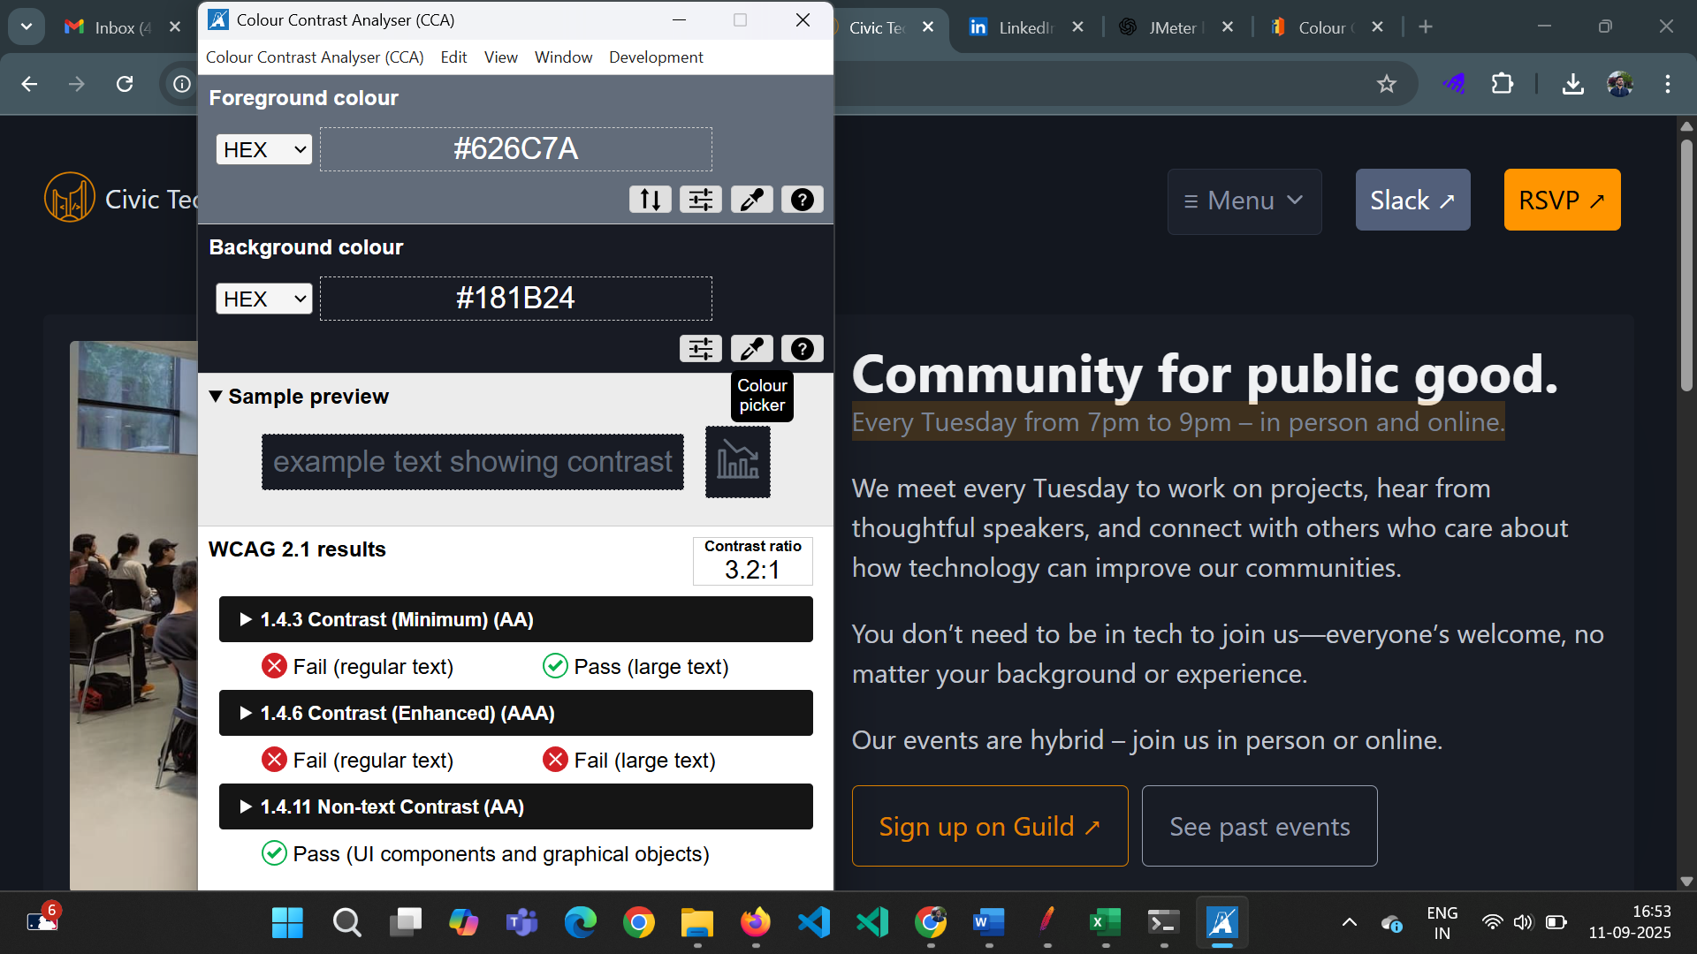

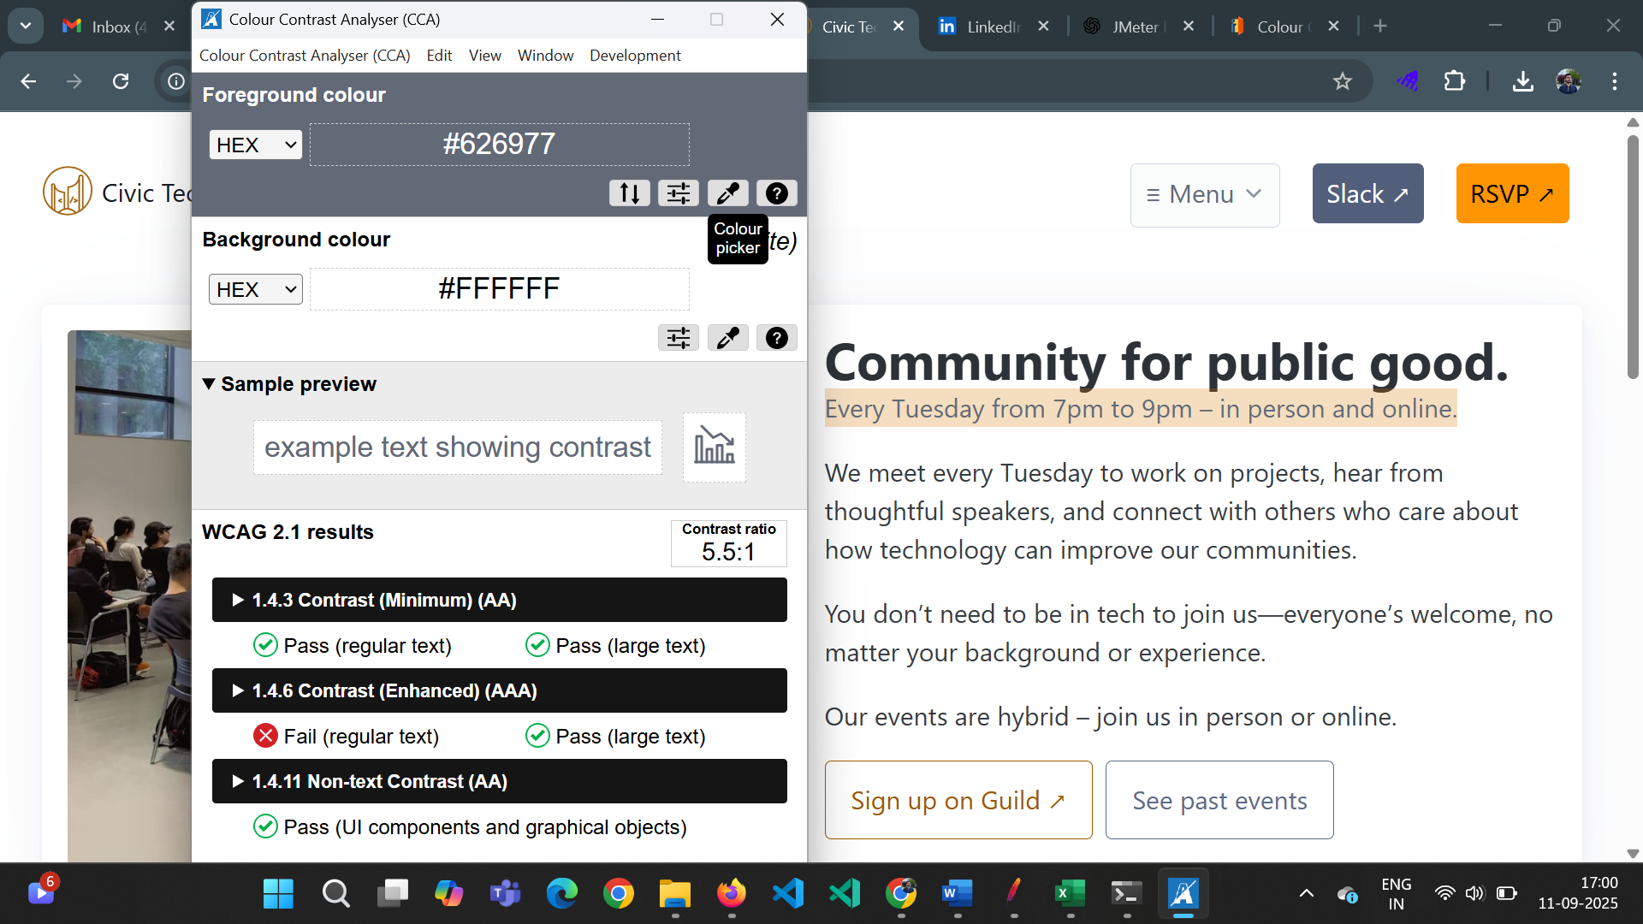

**Button – See past events**

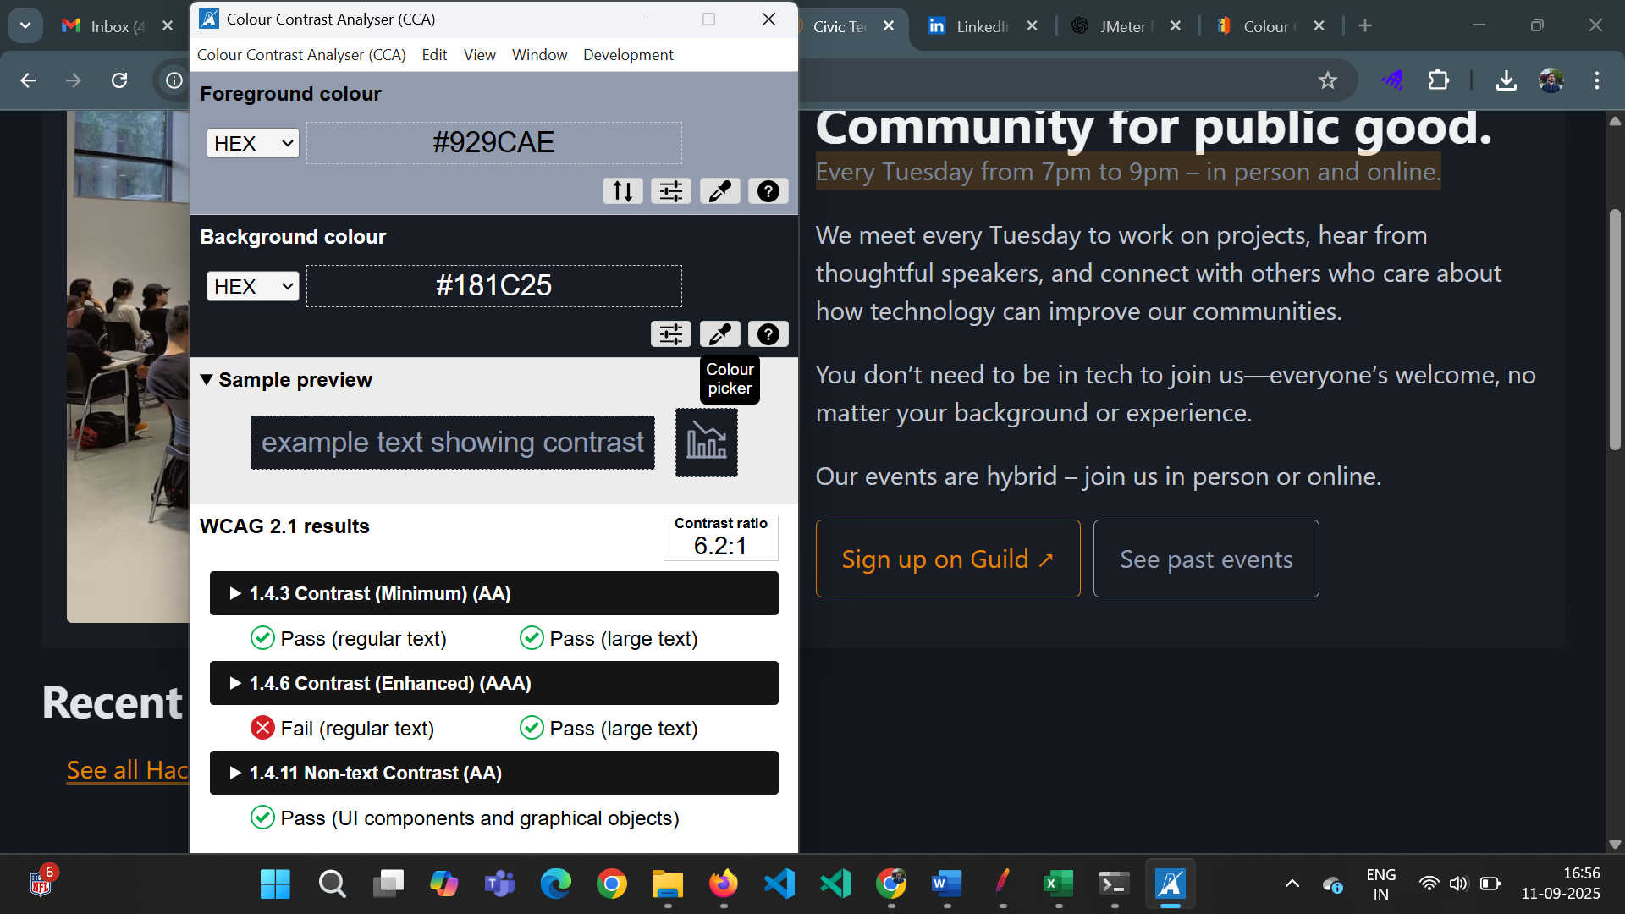

**Sign Up Button**

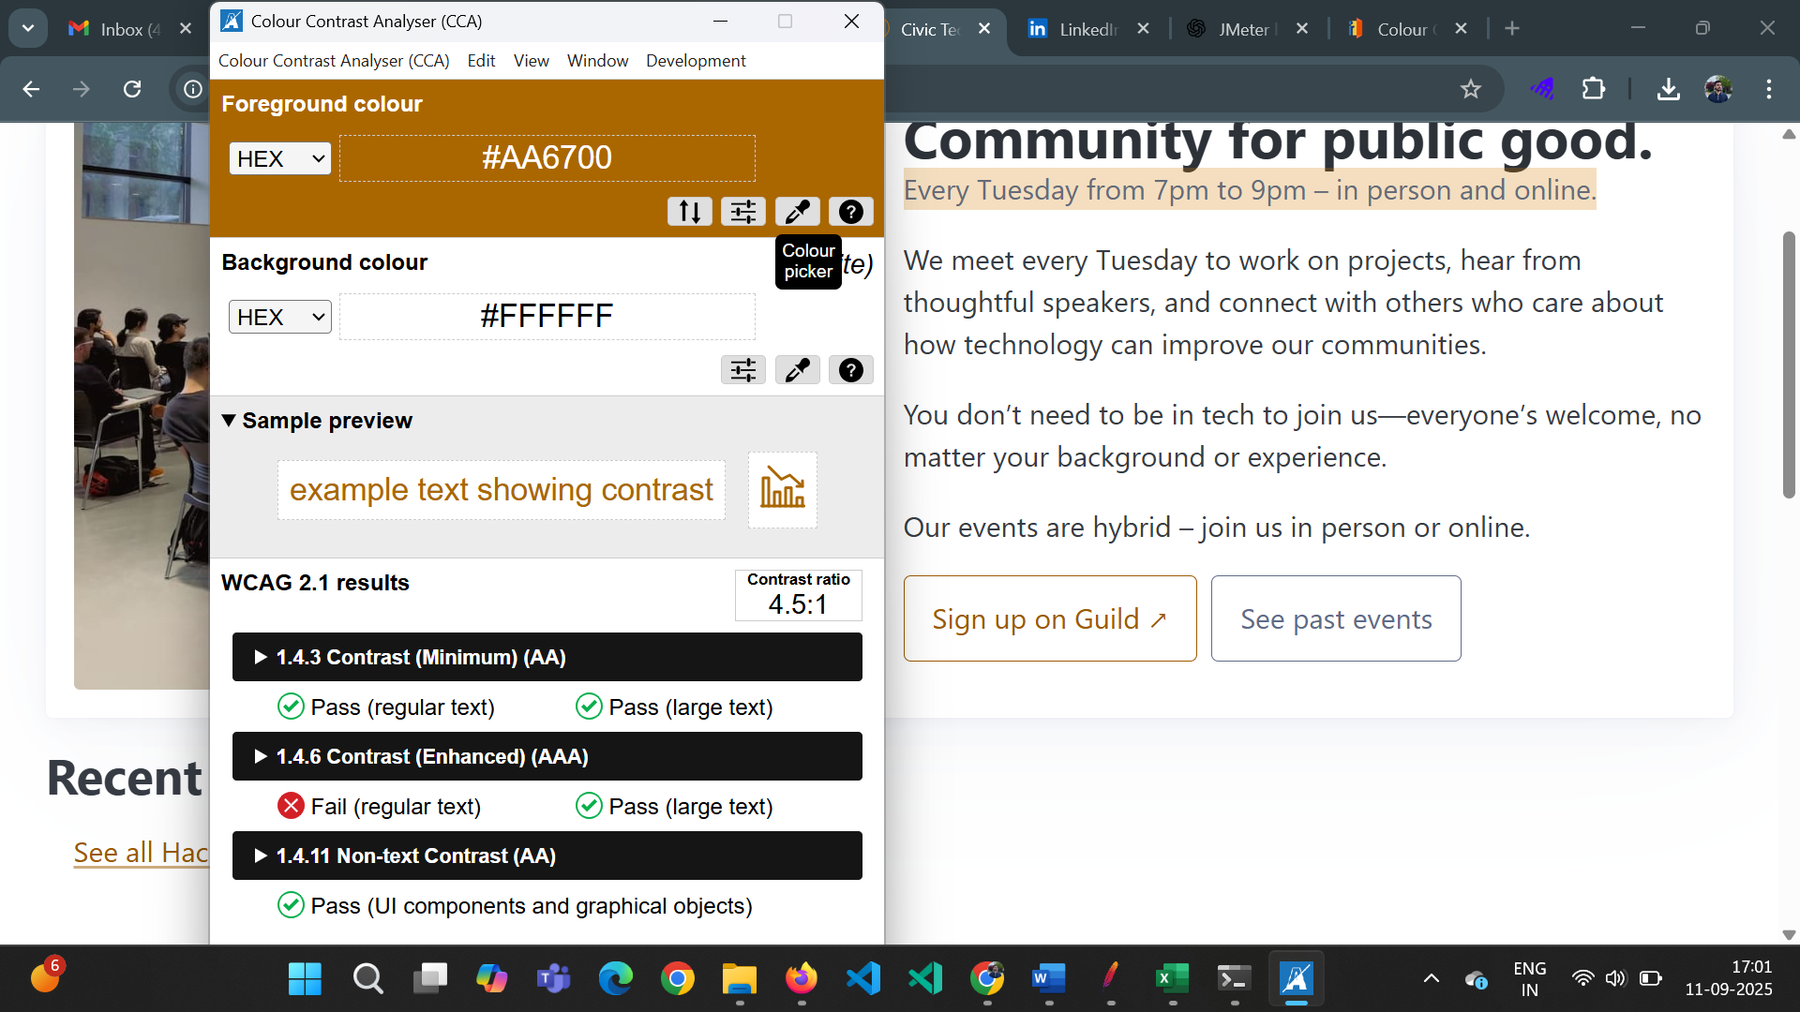

**Other Links – (e.g. See all Hacknights here)**

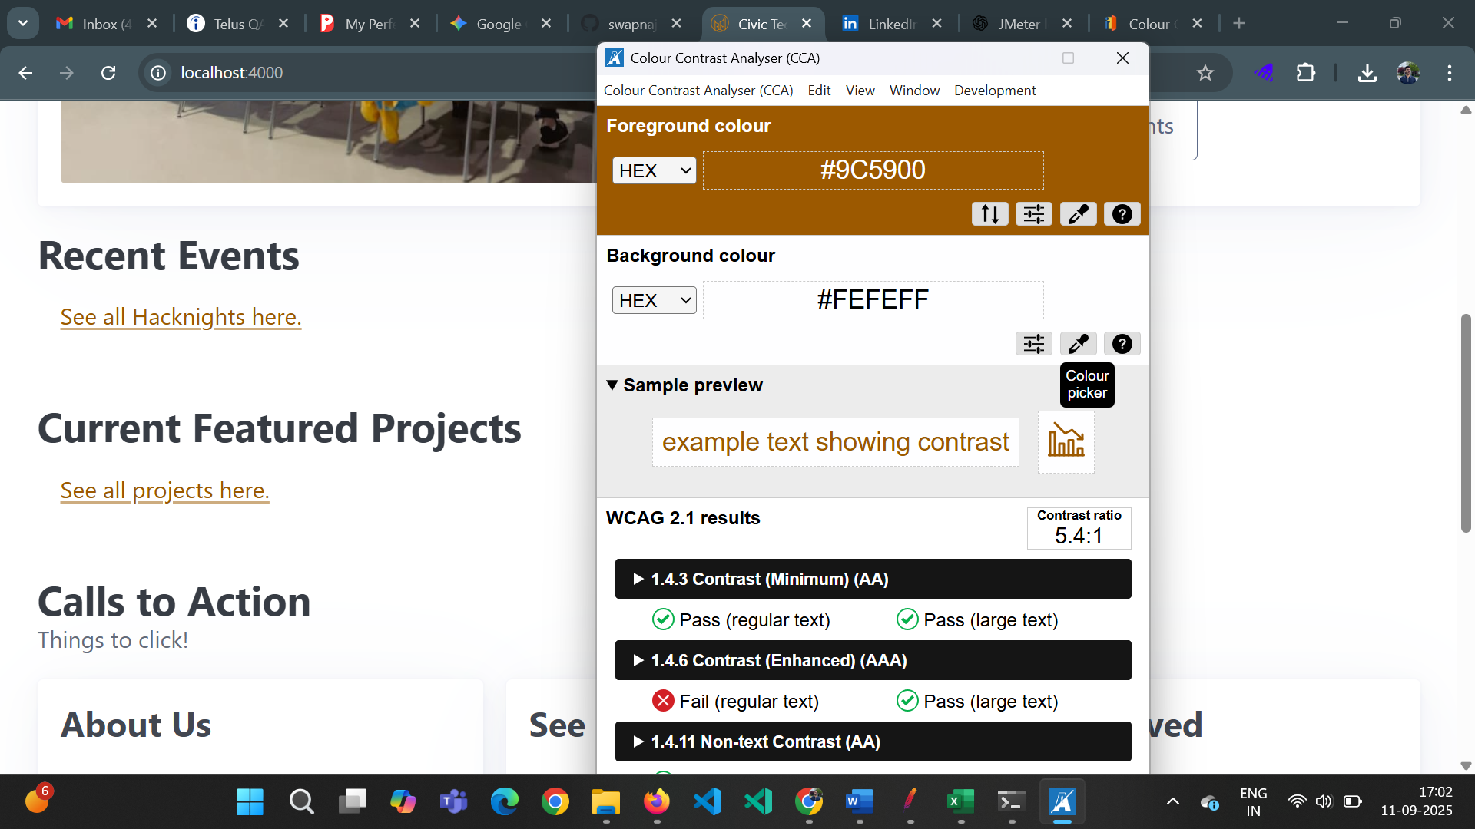

**Skip to Main Content**

